

**THE COUNCIL OF COMMUNITY COLLEGES OF JAMAICA**

ASSOCIATE DEGREE COURSEWORK

**SEMESTER II – JANUARY 2019**

**PROGRAMME: MANAGEMENT INFORMATION SYSTEMS,   
COMPUTER SERVICING AND ELECTRONICS**

**COURSE NAME: COMPUTER PROGRAMMING I**

**CODE: CPRG1205**

**YEAR GROUP: ONE**

**DUE DATE: WEEK OF APRIL 1 -5, 2019**

**UNIT: 2 - 7**

**ASSESSMENT TYPE: COURSEWORK 2**

**INSTRUCTIONS:** You are required to create an application for an electricity company to generate bills for their customers.

The attributes of the bill will include the following: -

* Premises Number=
* Account number=
* Account holder’s name=
* Account holder’s address=
* Previous balance
* Payments
* Balance brought forward
* Current charges
* Total amount due
* Statement date
* Due date
* Payment date
* Early payment discount
* Taxes
* Current reading
* Previous reading
* Current usage
* Rate =9.660
* Current period charges = current usage * rate

Charges to be calculated include: -

* Subtotal **= current period charges + customer charge**
* F/E Adjustment **= subtotal * fuel adjustment rate**
* Fuel and IPP Charges **= current usage * 21.794**
* Total current electricity charges before tax **= subtotal + F/E Adjustment + Fuel & IPP**
* Nontaxable charges
* Taxable charges
* GCT @ 16.5% on electricity charges
* Total current charges
* Total amount due

Your application should utilize **GUI components** and a **database** to create a solution to the problem. The electricity company meter reader will be required to input information for the following:

* customer’s current meter reading
* previous meter reading
* current usage rate
* Fuel Adjustment rate

Current charges for the period will be calculated as current usage times rate (**current charge** = current usage * rate). The rate for each customer is 9.660. There is a fixed customer charge of $455.

**Subtotal** of a customer’s bill is calculated as current period charges plus customer charge (subtotal = current period charges + customer charge).

**Fuel and IPP Charge** equal current usage times rate of 21.794 (Fuel & IPP charge = current usage * 21.794).

**F/E Adjust** equal subtotal times fuel adjustment rate (F/E Adjust = subtotal * fuel adjustment rate). The fuel adjustment rate will be entered by the meter reader.

**Total current electricity charges before tax** = subtotal + F/E Adjustment + Fuel & IPP charges.

**Nontaxable charges** are the same as the total current electricity charges before tax.

**Taxable Charges** is zero for all customers.

If current usage is less than 150 then no tax will be charged otherwise **GCT** is calculated at a rate of 16.5% on current usage.

If the customer pays their bill on or before the due date, they will receive an **early payment incentive** (discount) of $250.

**Total amount due** should be calculated and displayed.

Use appropriate formatting features to neatly display the bill information. See screenshot below, which can be used as a guide.

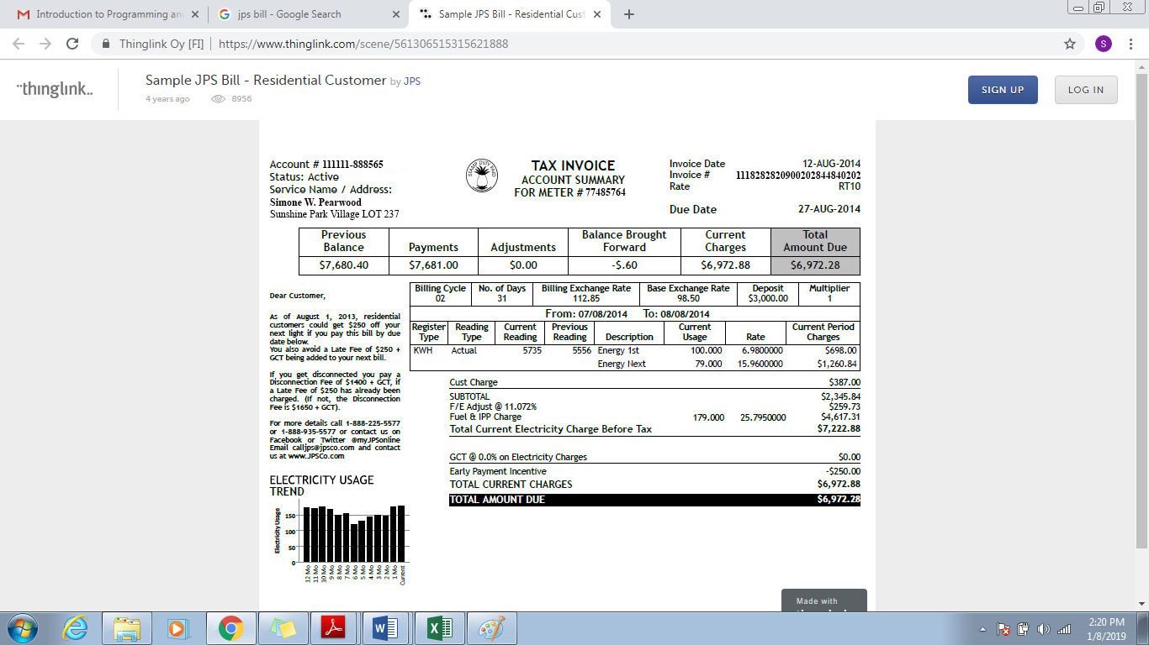

**MARK SCHEME**

|  |  |  |  |
| --- | --- | --- | --- |
| **Areas Assessed** | **Marks Allocated** | **Marks Received** | **Comments** |
| Login Screen (must have at least two logins) | 4 |  |  |
| Create an appropriate database | 4 |  |  |
| Use Appropriate Data Types | 2 |  |  |
| Create at least three tables | 6 |  |  |
| GUI | 6 |  |  |
| Correct Inputs | 4 |  |  |
| Correct Processing   * Current charge * Sub total * GCT * Fuel and IPP Charge * F/E Adjust * Total Current Electricity charge before tax * Early Incentive payment * Total Amount due | 2  2  2  2  2  3  1  2 |  |  |
| Correct Output | 4 |  |  |
| Use of appropriate SQL commands | 4 |  |  |
| **Total Marks** | 50 |  |  |